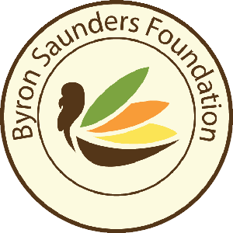

Dear Sir or Madam:

The Byron Saunders Foundation is a non-profit organization created with the mission of providing Thanksgiving meals to families in need in Central Ohio and surrounding counties. We count on the generosity of the community to help make this possible. During the holiday months, the need for assistance to families increases. It is with the community support through volunteer time, food and monetary donations that we are able to provide over 5,000 families a Thanksgiving meal last year.

Our second annual themed event, “Come to Our Thanksgiving Table” will take place on Thursday, October 4, 2018 at the exclusive Heritage Golf Club, located at 3525 Heritage Club Drive in Hilliard, Ohio. A wonderful Thanksgiving meal will be served to all of our guests, and we are featuring famed Country Music star, Mr. Jimmy Wayne, as our featured speaker. This year, we are looking to raise $150,000 to feed 6000 families.

We can’t meet our goal without the help of people and companies like yours.

That’s why I am writing to you. Would you consider making a donation and becoming one of our exclusive sponsors? By giving to the “Come to our Thanksgiving Table” event, you’ll be able to make a significant impact to our community by helping feed hungry families at Thanksgiving this year.

In appreciation of your anticipated donation, we have exclusive sponsorship levels available, I have attached for your consideration.

We hope that we can count on your help to make this year’s event the best yet!

Thank you in advance for your contribution. We hope to see you & you will “Come to Our Thanksgiving Table”.

For Questions or More Information, Please Contact our Event Co/Chairs
Bren Wolfe Sharon Prince
720.933.9182 850.508.9527
BrenWolfe@outlook.com Sprince89@yahoo.com

